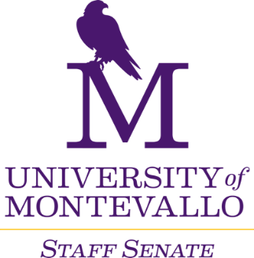

**Thursday, November 7, 2024**

**Merrill Room**

**10 a.m.-12 p.m.**

**AGENDA**

1. Welcome
2. Approval of minutes
3. Old Business
   1. Senate Divisions reminder
   2. Staff Salary Policy & Board of Trustees meeting
   3. Staff Performance Evaluations
4. Reports from Liaisons
   1. Swell Being Wellness Week recap, Kacie Slaughter
   2. Additional updates?
5. Reports from Committees
   1. Campus Communication
   2. Events, Services, and Recognition – bricks, convocation
   3. Finance and Staff Salary Review
   4. Policies and Procedures
   5. Professional Development – 360 evaluations
6. Reports from Departments
7. Next Meeting
   1. December 5, 2024
   2. January 9, 2025